Undergraduate Research Proposal




AI-Powered Cricket Batting Performance Analysis and Recommendation System for Sri Lankan Players

A.W.T.C.D. WANIGASEKARA
KIC-BSCCSAI-251P-007

Kandy Innovation Centre, National Institute of Business Management, 1095, Kandy - Colombo Rd, Getambe.
16th August 2026
Table of Contents
1. Details of the Individual Research Project 3
1.1 Proposed Study Title 3
1.2 Details of the Researcher 3
1.3 Details of Internal Supervisor 3
1.4 Details of External Supervisor 3
2. Introduction 4
2.1 Background Information 4
2.2 Research Problem 5
2.3 Rationale 5
2.4 Research Gap 6
3. Objectives 7
3.1 Primary Objective 7
4. Proposed Research Methods 8
4.1 General description of the study field 8
4.2 Research Questions 8
4.3 Methods for Data Collection 8
4.4 Methods for Analysis of Data 10
4.5 Methods for Implementation of the Solution 10
4.6 Expected Results and Applications 11
4.7 Methods of Comparing the Models and Results 11
4.8 Resources 12
5. Timeline 13
6. References 14

1. Details of the Individual Research Project

Proposed Study Title
AI-Powered Cricket Batting Performance Analysis and Recommendation System for Sri Lankan Players.

Details of the Researcher
- Aranwala Wanigasekara Tanthirige Chanuka Dananjaya Wanigasekara
- Institutional Affiliation: Kandy Innovation Centre, National Institute of Business Management, 1095, Kandy - Colombo Rd, Getambe.
- KIC-BSCCSAI-251P-007
- +94715986908
- chanukawanigasekara007@gmail.com

Details of Internal Supervisor
- Name:
- Institutional Affiliation(s): Kandy Innovation Centre, National Institute of Business Management, 1095, Kandy - Colombo Rd, Getambe.
- Telephone Number:
- Email Address:

Details of External Supervisor
- Name:
- Institutional Affiliation(s): Kandy Innovation Centre, National Institute of Business Management, 1095, Kandy - Colombo Rd, Getambe.
- Telephone Number:
- Email Address:

2. Introduction

2.1 Background Information
Cricket analytics has expanded rapidly because detailed cricket data and modern machine learning methods can support player evaluation, tactical decisions, and performance prediction. A systematic review of cricket ML research published between 2001 and 2021 found substantial growth in applications such as match outcome prediction, player performance prediction, team selection, and sensor assisted analysis. These developments show that data driven methods can complement coaching observation with reproducible evidence (Wickramasinghe, 2022).
Recent batting analysis research has mainly emphasized video, image, audio, deep learning, and human pose estimation pipelines. For example, one study extracted body keypoints from cricket videos and compared ML and deep-learning models for classifying eight batting strokes, while another survey found that the literature was dominated by convolutional neural networks and multimodal video based features. Although these approaches can achieve high classification accuracy, collecting, annotating, storing, and processing video can require cameras, suitable footage, specialist preparation, and greater computing resources. These practical requirements can reduce accessibility for school, university, club, and amateur players with limited budgets. (IEEE, 2025) (Hafeez Ur Rehman Siddiqui, 2023)
This research, hence, proposes a budget friendly system for batting coaching using AI, which analyses the performance of the player every match with structured records of the innings instead of continuous video recording, body sensor wearing or specific hardware. Recent scores, strike-rate, consistency, dismissal type, bowling length and line, choice of shot, match context and repeated combinations of dismissal. It will then be able to estimate current batting form, pinpoint any recurring weaknesses, and give specific coaching suggestions.
The research dataset will be manually constructed from real match records available through public scorecards and ball-by-ball commentary. Each row will represent one player's innings in one match, allowing chronological, match-by-match analysis rather than a single aggregated career summary.

2.2 Research Problem
Many amateur and semi-professional cricketers can access scorecards containing runs, averages, and strike rates, but these summaries do not by themselves explain why a player's performance changes from one match to the next. Players need a practical way to connect innings outcomes with dismissal type, bowling characteristics, shot choice, and match context so that recurring weaknesses can be identified over time.
The reviewed research demonstrates the value of ML in cricket, but much of the batting-specific work concentrates on detecting or classifying strokes from video and multimodal data. The wider cricket ML literature also gives considerable attention to match outcomes and aggregate player prediction and reports inconsistent disclosure of dataset and evaluation details. A clear opportunity therefore remains for a transparent, affordable system that uses sequential match records to evaluate individual batting form, discover recurring dismissal patterns, and convert those findings into player-specific coaching advice.
Therefore, this research seeks to determine whether lightweight supervised ML models can transform readily obtainable match-by-match batting data into useful form ratings, weakness profiles, and personalized recommendations without depending on a costly video-analysis or sensor infrastructure.

2.3 Rationale
AI has proven to be a powerful asset in sports analytics, offering a more objective means of evaluating performance and informing decision making. AI can be used in cricket batting analysis to help identify weaknesses in the game that may not be apparent through traditional coaching approaches.
The system being proposed will help the players by studying their pasts and making suggestions on how to improve their batting. These suggestions can be used to enhance shot selection as well as reduce repeated dismissals and gain insight into the player's present batting ability.
The system will also enable the cricket coaches to get more analytical insights to help them make evidence based coaching decisions. The system uses publicly available cricket data and the machine learning techniques, making it a cost-effective solution for school, University and club level cricket.

2.4 Research Gap
Previous work has shown that ML can be useful for cricket analytics. However, most of the existing work focuses on modeling match outcomes, predicting aggregate performance, or using resource intensive video, image, audio, pose estimation, and deep-learning pipelines. It doesn’t sufficiently cover an accessible coaching tool that tracks a particular batter over several games, incorporating recent performance trends and recurring dismissal patterns to provide customized advice. This project addresses that gap with a low-cost design that uses public scorecards, commentary, open source software, and common hardware; match-by-match, innings-level analysis that preserves chronology rather than aggregate career statistics; transparent comparison of lightweight supervised models; and recommendations explicitly tied to detected evidence. (Hafeez Ur Rehman Siddiqui, 2023) (IEEE, 2025) (Wickramasinghe, 2022)

3. Objectives

3.1 Primary Objective
To develop an AI-powered personalized coaching system for cricket batting that can analyses historical batting statistics, evaluate the performance of the player, identify the area of weakness in their batting and offer personalized tips based on the analysis using machine learning techniques.

4. Proposed Research Methods

4.1 General description of the study field
This research lies at the intersection of Artificial Intelligence, Machine Learning, Sports Analytics, and Software Engineering. Unlike video-based stroke classification studies, it focuses on supervised learning from structured, sequential match records. The project also includes a web application for player registration, innings level data management, form and weakness visualization, and evidence-linked recommendations. (Hafeez Ur Rehman Siddiqui, 2023) (IEEE, 2025)

4.2 Research Questions
RQ1: Can machine learning accurately identify batting weaknesses using historical batting performance data?
RQ2: Can historical batting performance be used to evaluate a player's current batting form?
RQ3: Can AI-generated recommendations provide meaningful coaching advice for improving batting performance?

4.3 Methods for Data Collection
Data for the dataset will be manually created from historical batting performance data from real cricket games played by Sri Lankan players. The study will particularly focus on Sri Lankan batsmen, their data will be collected from the available website sources in the cricket world like ESPN Cricinfo, Cricbuzz, CricHeroes, ICC Match Centre and Ball by Ball Match Commentary.
Each record in the dataset will represent a single batting inning. Basic batting statistics, including runs scored, balls faced, strike rate, dismissal type, and match information, will be collected directly from scorecards. Additional attributes such as bowling length, bowling line, and shot type will be manually identified through ball-by-ball commentary and match videos where necessary.

The proposed dataset will contain fields including:
- Player ID
- Match ID
- Innings Number
- Runs
- Balls Faced
- Strike Rate
- Out / Not Out
- Dismissal Type
- Bowling Length
- Bowling Line
- Shot Type
- Bowler Type
- Match Format

Additional attributes may be included if relevant information is available.

4.4 Methods for Analysis of Data
The data collected will be preprocessed and feature engineered, cleaned and made consistent, filled with missing values and encoded, before being used.
Various machine learning algorithms, like Random Forest, Decision Tree and Logistic Regression, will be tested for identifying the weaknesses of the batters and classification of the performances of the players. Historical batting metrics such as recent performance, strike rate, dismissal rate, consistency etc. will be used to gauge the player's batting performance.
The models will be tested on Accuracy, Precision, Recall, F1-Score and Confusion Matrix to assess the best model using developed models.

4.5 Methods for Implementation of the Solution
The proposed system will be developed as a web-based application.
The front end will be built with React.js and the back end will be built with Python Flask to help integrate the machine learning models with the application. MySQL will be used as the database management system for storing player profiles and batting performance data.
The implementation process consists of:
- Player registration and authentication.
- Manual entry of batting performance data.
- Data preprocessing and feature extraction.
- Machine learning prediction.
- Player form evaluation.
- Batting weakness analysis.
- Personalized coaching recommendation generation.
- Visualization of player performance through dashboards and charts.

4.6 Expected Results and Applications
The proposed system is expected to:
- Evaluate a player's current batting form using historical match data.
- Identify recurring batting weaknesses and dismissal patterns.
- Predict areas where the player is more likely to lose their wicket.
- Generate personalized coaching recommendations based on AI analysis.
- Provide graphical visualizations of batting performance over time.
The system can be used by schools, universities, clubs, and amateur cricketers as an affordable coaching support tool and may also assist cricket coaches in making evidence-based coaching decisions.

4.7 Methods of Comparing the Models and Results
Multiple machine learning models will be trained and evaluated using the same dataset. Their performance will be compared using:
- Accuracy
- Precision
- Recall
- F1-Score
- Confusion Matrix
The model with the highest predictive performance and generalization capability will be selected for deployment within the system.

4.8 Resources
Hardware
- Personal laptop
- Internet connection
Software
- Visual Studio Code
- Python
- React.js
- MySQL
- Git
Python Libraries
- Pandas
- NumPy
- Scikit-learn
- Matplotlib
- Flask
Data Sources
- ESPN Cricinfo
- Cricbuzz
- ICC Match Centre
Other Resources
- Ball-by-ball match commentary
- Match highlights for manual verification of shot type and bowling length

5. Timeline
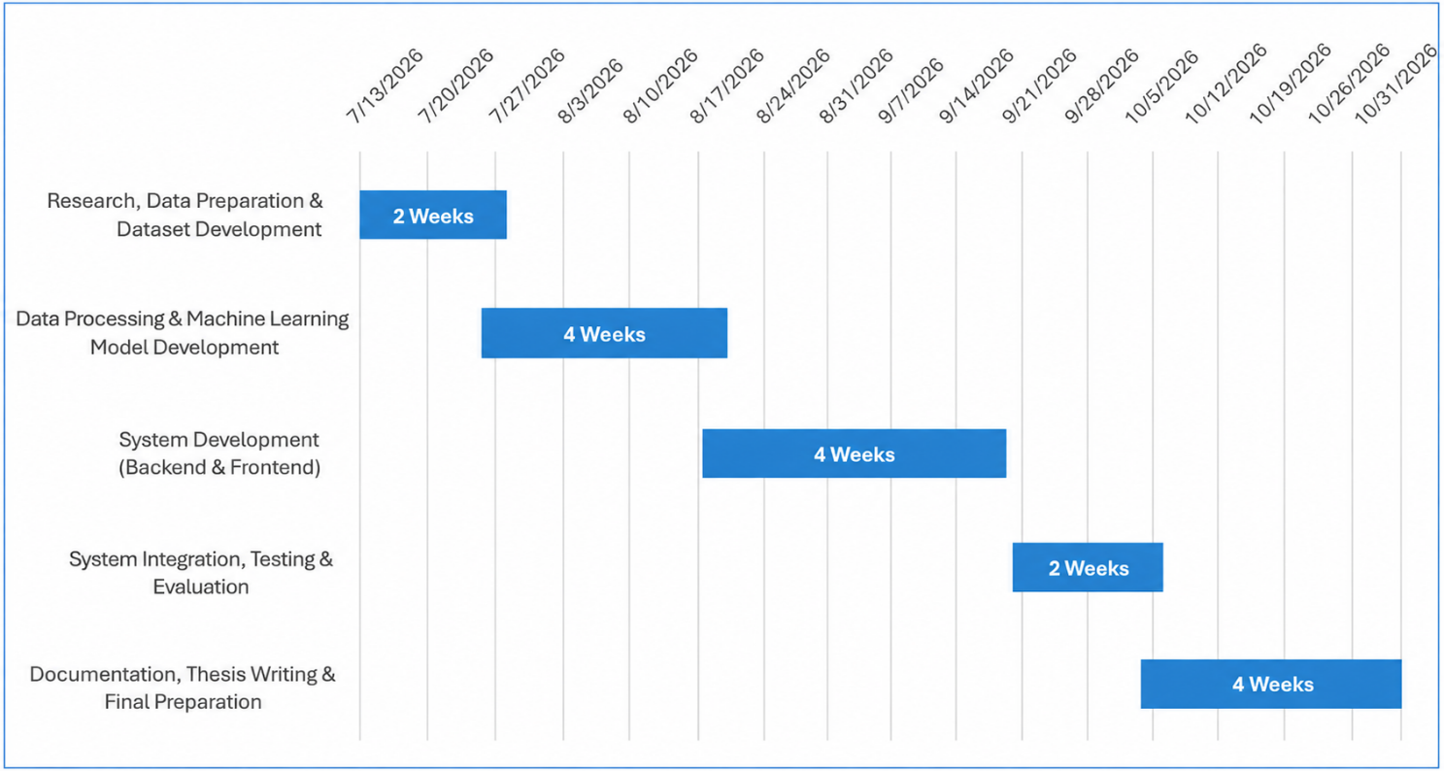

6. References

- Hafeez Ur Rehman Siddiqui, F. Y. (2023, August 1). Enhancing Cricket Performance Analysis with Human Pose Estimation and Machine Learning. Retrieved from MDPI: https://www.mdpi.com/1424-8220/23/15/6839
- IEEE. (2025, September 17). Shot Detection and Performance Analysis in Cricket. Retrieved from IEEE Xplore: https://ieeexplore.ieee.org/abstract/document/11158240
- Wickramasinghe, I. (2022, December 15). Machine Learning with Applications. Retrieved from ScienceDirect: https://www.sciencedirect.com/science/article/pii/S2666827022001104

